**AGENDA**

**Pioneer Fire Protection District**

**Board Meeting**

**Thursday, November 30, 2017 – 6:00PM**

**7061 Mount Aukum Rd., Somerset, CA 95684**

Welcome to the Pioneer Fire Protection District Board Meeting. The Chairman of the Board of Directors will invite your comments regarding any item listed on our open session agenda. The Chairman may request that comments be limited to three (3) minutes for any item NOT listed on the agenda. The Brown Act prohibits the Fire Board from taking any action not listed on the agenda.

**1.0 CALL TO ORDER**

Roll Call

Salute to Flag

Adoption of Agenda

**2.0 PUBLIC COMMENT OTHER THAN AGENDA ITEMS**

**3.0 UNFINISHED BUSINESS**

3.1 Minutes from Special Board Meeting – November 3, 2017

**4.0 NEW BUSINESS**

4.1 County wide Sales Tax for county fire districts – Chief Dwyer

Overview from the Chief, discussion of financial contribution and related pros/cons.

Motion and Roll Call vote regarding position on the plan and the potential expense to PFPD

4.2 Final review and potential amendment of the job postings documents for the Chief’s position

Motion to approve

4.3 Discussion and feedback on interim coverage plan for Chief’ position and duties starting

January 1, 2018 – Chief Dwyer

**5.0 ADJOURN MEETING**

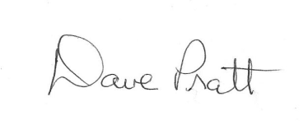

____________________________

Board Signature

Note: All Board meetings are recorded. The agenda is available on the District’s web site (www.pioneerfire.org) and the full agenda packet may be viewed at the District’s main office, Station 38, 7061 Mount Aukum Road, Somerset between 9AM and 1PM. Station 38 has disabled access and facilities.